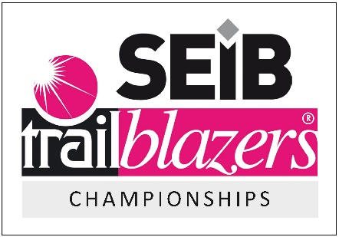
BBDRC Express Dressage League 2022 with SEIB Trailblazer Championships Qualifier.
Kirkley Hall Equestrain Centre, Northumberland, NE20 0AQ.
Sponsored by Dressage Riders Online.

TEAM ELEMENT
A team is made up of 4 riders and can choose which tests they all do, for example, one team may enter all riders riding a novice test, one may enter all riders riding elementary, and another may enter a team with one rider at each test level. Team scores will be calculated using the percentage from each test added together. All four scores to count.

Team members are also entered in as an individual competitor within one test only in the selected section and must be submitted on entry to Equo Event Profile. So If you are entering as a team, please only enter 1 individual test if you are wanting to compete in two classes. So if you are a non-member you are saving yourself £3.

PLEASE CAN WE ASK THAT YOU COMPLETE THE BELOW FORM AND RETURN TO Victoria.conwaybbdrc@gmail.co.uk.

TEAM NAME:
 | RIDER NAME | HORSES NAME | TEST
TEAM MEMBER 1:
TEAM MEMBER 2:
TEAM MEMBER 3:
TEAM MEMBER 4:

